Assignment - 3

|  |  |
| --- | --- |
| Student Name/ID Number: | Huynh Minh Phu - PGSE0823 |
| Unit Number and Title: | Module 4 – Web Development Foundations |
| Academic Year: | 2023 |
| Unit Assessor: | Module 4 |
| Project Title: | Code the forms in Spring and Link it to MySQL Database |
| Issue Date: | 18/03/2024 |
| Submission Date: | 18/03/2024 |
| Internal Verifier Name: |  |
| Date: |  |

|  |
| --- |
| **Learner declaration** |
| I certify that the work submitted for this assignment is my own and research sources are fully acknowledged.  Student signature: Phu Date: 20/03/2024 |

|  |
| --- |
| **Purpose of this project** |
| **Purpose of this project**  To demonstrate your capabilities in the following areas:   * Code the Spring created in Mini Project 2 to integrate with database & with full functionality for the following   + Registration   + Update Profile   + Login & Log Out |
| **Submission Format** |
| 1. Screen capture of the working Registration, Update Profile, Login & Logout |
| **Project Brief & Guidance** |
| **Scenario:**  **Refer to the Project Scenario for the Module Project**  You currently work as a *Data Engineer* for Brightica design agency, where you design and implement data models for client-centric products. As part of the role, your manager Mr. Andrew assigned the project to develop an optimal database design to deliver Rich Internet Application for boutique. Boutique is a marketplace for sellers to promote their products and for consumers to purchase with ease. The company wants to have a consumer-centric application with an enhanced user experience.  The scope of the project in this module is for development of Spring Website.  **The overview of the project is as below**  The overview of the project is as below There are 3 types of users   1. Sellers 2. Consumers 3. Administrator   Sellers should be able to perform following functions in the portal   1. Register in the portal 2. Update their Profile after logging in 3. Maintain the product catalog to promote their products |

|  |
| --- |
| Consumers should be able to perform following functions in the portal   1. Register in the portal 2. Update their Profile after logging in 3. Search products 4. Choose products to view the details 5. Shopping cart to add, review, and remove items   Administrator should be able to perform following functions in the portal   1. Administer user data. 2. Send bulk email invite to potential clients to register   **The scope of this assignment**  The scope is to develop coding on the Spring Project in Mini Project 2, Integrate the registration page with the database & create the models as required.   * 1. Create registration page   2. Create update profile page   3. Create the login system   Provide Screen capture of the working Registration, Update Profile, Login & Logout |

**The scope of this assignment**

The scope is to develop coding on the Spring Project in Mini Project 2, Integrate the registration page with the database & create the models as required.

1. Create registration page

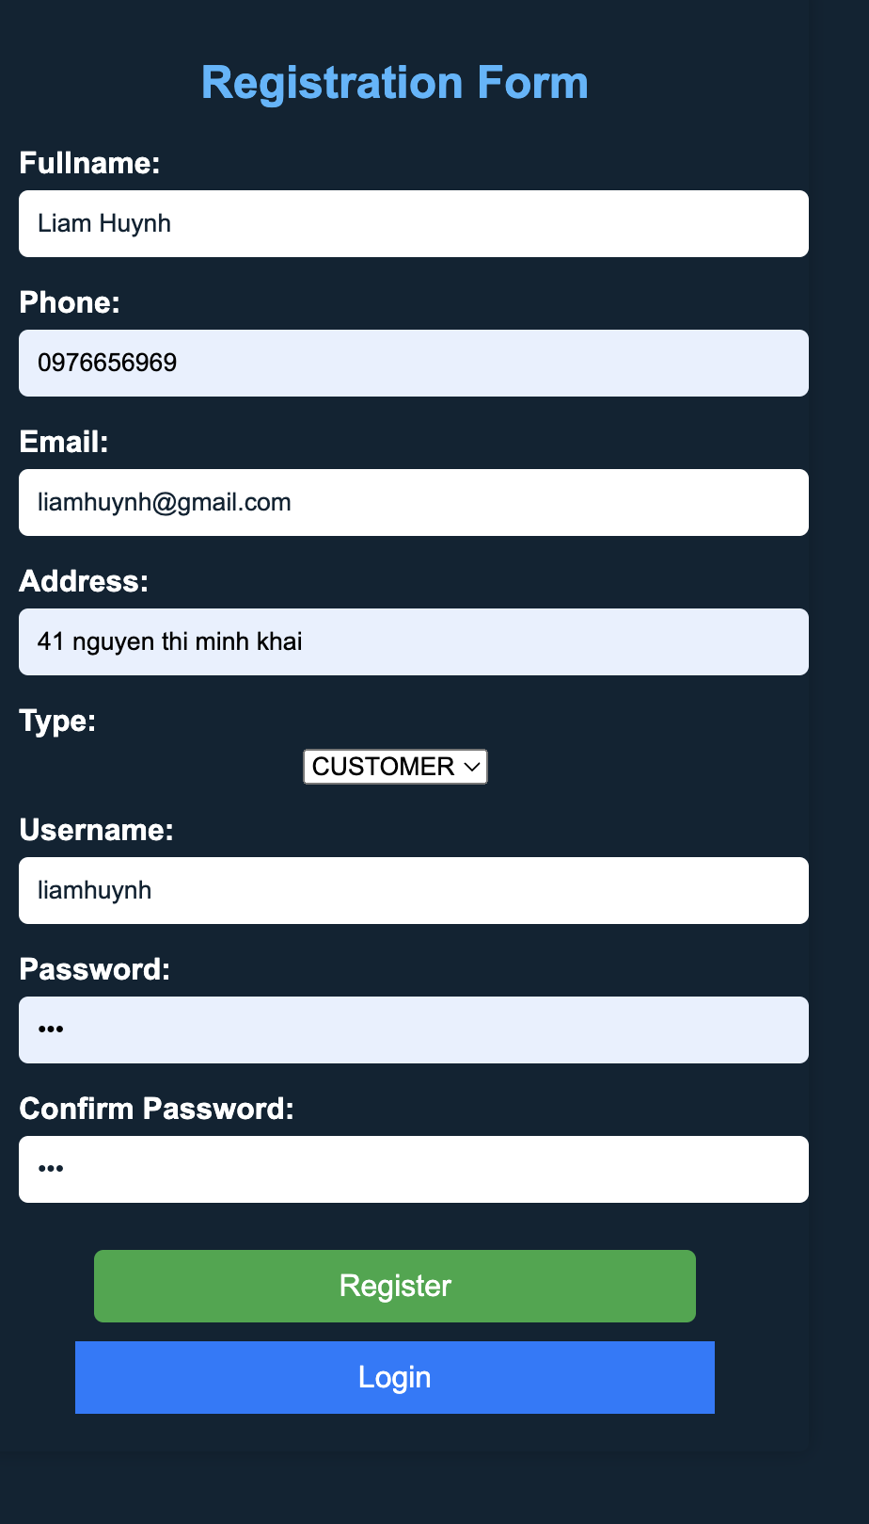

1. Create update profile page

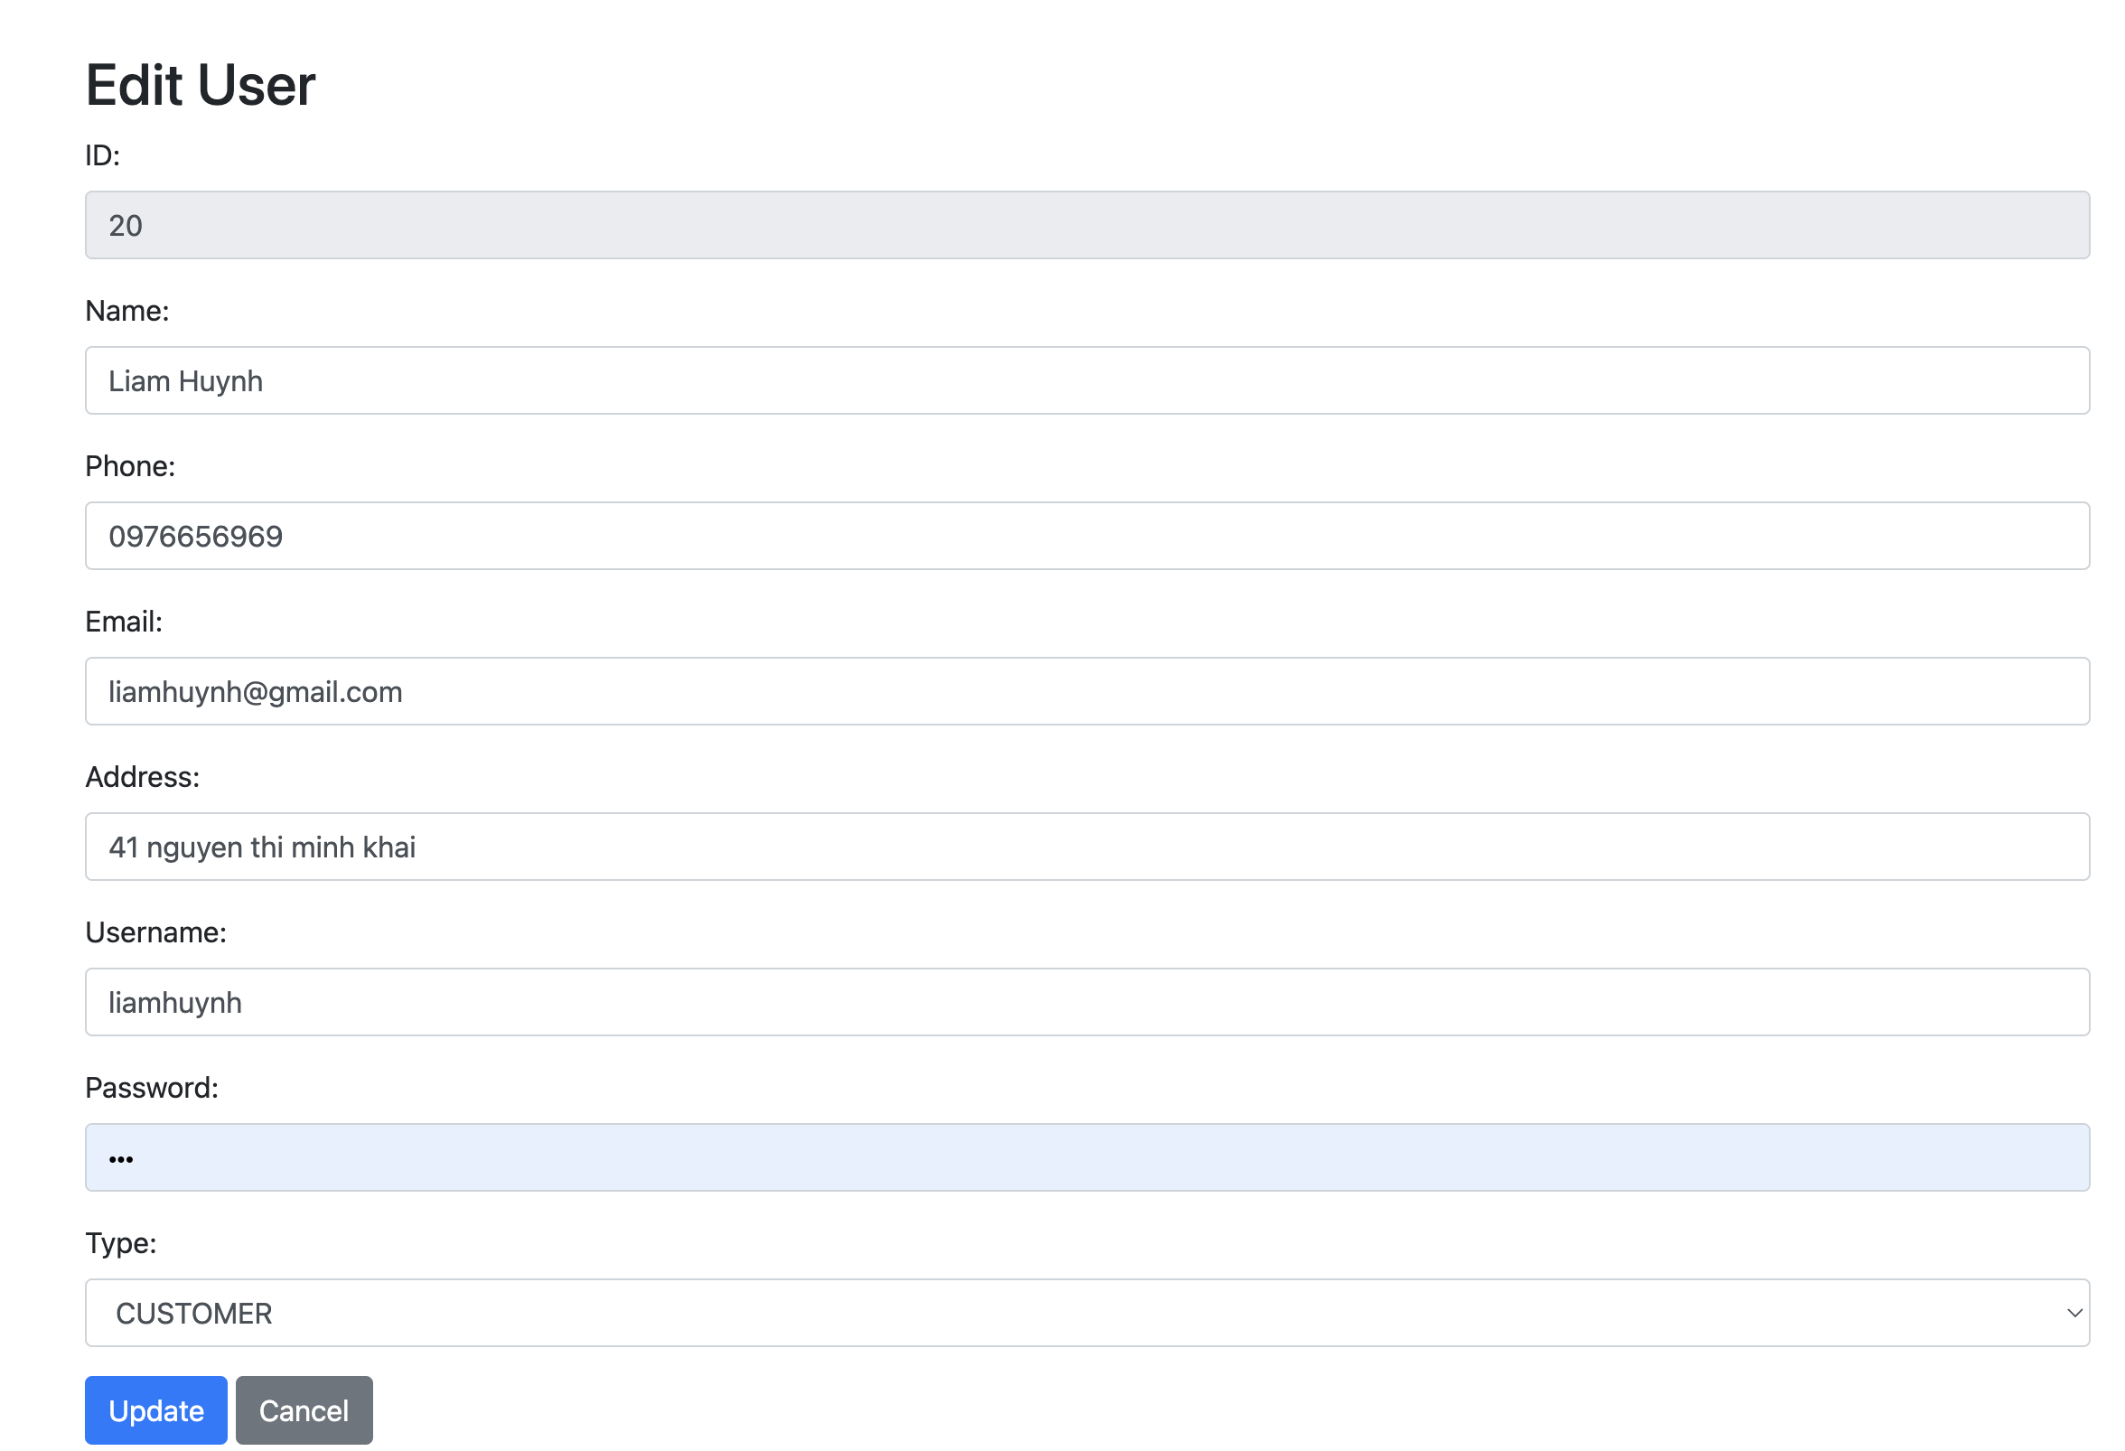

1. Create the login system

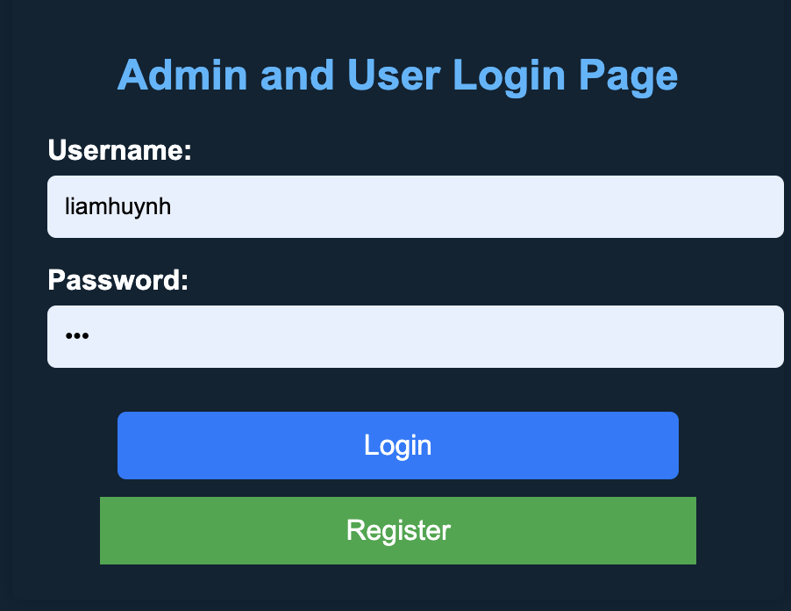

1. Logout

